Cemeteries and Cremation Acts Review

The management of human remains is an essential community service for which current methods are environmentally unsustainable and create financial burden for many members of the community.
Our focus is on:
- Topic 2: Alternative methods for the disposal of human remains
- Topic 4: Burials outside of proclaimed cemeteries, particularly 4B

We encourage you to consider this submission and respond to community preferences for more affordable and sustainable practices within the death care industry that improve community wellbeing, address economic disadvantage and environmental sustainability.

Traditional practices around death, dying, funeral care, burial and cremation are not meeting the needs of a growing segment of the West Australian population. Market demand for compassionate funeral care, affordable funerals and funerals with a low environmental footprint is growing.

Transition to more environmentally friendly options for body disposal

There is considerable need to offer more environmentally friendly options at all stages of the death journey and supporting the sector moving towards carbon neutral service models. This will require reducing the reliance on fossil fuel burning cremators and offering greener body disposal options.

There has been a significant rise in popularity for cremations in Australia with around 75% of funerals now involving a cremation which release carbon emissions; rely on single-use products (coffins) and cause environmental pollution. In Perth crematoriums are heated to 980 degrees celsius before the casket or coffin is passed through. The cremation takes around 1.5 to 3 hours to complete. With the average cremation taking two hours, there is a significant energy requirement in creating and maintaining this heat. The energy source for cremation is typically natural gas.

As a fossil fuel driven process, cremation produces significant amounts of carbon dioxide. One cremation is estimated to produce 240kg of CO2. This is the equivalent of a 980km car journey in an average sized car. The cremation combustion processes also generates potentially harmful pollutants such as mercury, organic compounds and fine particulates due to the dental fillings and metals and plastics that form part of caskets. While there are some measures taken to prevent or reduce pollution in the process, cremation remains fundamentally pollutive.

Standard burials use single-use products (timber coffins) and are the most expensive option for body disposal and are being impacted by limited land availability in some areas.

Greener and more affordable options exist:

Soil transformation, also known as natural organic reduction and human composting, involves the gentle transformation of a body into nutrient-rich soil. It disposes of people’s remains in a respectful carbon neutral way, reducing pollution (metals, plastics and lacquers) to the atmosphere or land and forest depletion for wood caskets. It creates a product that strengthens and improves the environment rather than depleting it.

Families can keep the soil – to scatter or plant – and any remaining soil can be used for land conservation purposes and community projects. This option is being increasingly used in the United States (see Recompose). Interest is growing in Australia with a proof of concept project receiving funding in the ACT.

Many people want to be buried in the place they belong to, in an environmentally responsible future focused way, but there has been a lack of creative thinking around different options to the two primary options of cremation or burial in a designated cemetery.

Currently in WA, natural burial areas are becoming increasingly available, but are restricted to existing cemeteries and equally expensive as normal burials. Moreover, natural burials grounds are not clearly linked to broader conservation goals.

Natural burials in other parts of Australia and the world often use a shroud (clothe) to cover a body before being buried into the ground (see https://youtu.be/BKBtSfmUmKA?si=YAeypHDCgZUjx6Ct). This practice reduces cost and environmental footprint, and nutrients are released quickly from the decomposing corpse and can contribute to regenerative land practices. Natural burials are allowed at a limited number of sites across WA but the option of using a shroud is not available. There is significant interest in the integration of natural burial zones and rehabilitation corridors through the practice of conservation burial.

Partnerships between conservation bodies such as Gondwanna Link , local Landcare groups and Indigenous Ranger groups could support conservation burials through the creation, and also maintenance and restoration, of wildlife corridors. A conservation burial is a natural burial but serves a significant conservation purpose by giving people both the desire and capacity to continue to care into the long term for their buried loved ones and Country at the same time. Like elsewhere in the world (see www.conservationburialalliance.org/our_mission.html), conservation burials in WA could be trans-generational, with the potential to build ongoing Care of Country for families and communities over long enough time (centuries) to thoroughly restore damaged landscapes. If the process for applying for burials was simplified, we believe many rural communities and especially Indigenous people would be able to bury their loved ones on Country for much reduced cost and in alignment with traditional rites.

Both human composting and conservation burial practices benefit from efficient body disposal (eg within a 5 day period) which has a flow on effect of reducing the need for toxic embalming practices and storage.

Additional conservation opportunities

When considering fire based cremation processes additional environmental benefits can be achieved by using unclaimed ashes for community projects such as reef balls (eg www.eternalreefs.com).

Cremation is very carbon hungry and polluting as detailed previously. Both natural burials within conservation burial areas and human composting could be tied to a carbon credit program(s) to provide economic incentives.

Assuming success in the national renewable electricity target of 82% by 2030, electrification of traditional gas crematoriums could be fast tracked in order to achieve significant emissions reductions by a similar timeframe. A process of renewable energy certification would be undertaken with notification to consumers of this status required by the funeral industry.

Affordability
It is also important to consider many people in low socio-economic bracket have great difficulty meeting funeral costs. This is particularly true for Indigenous people who have lower life expectancy and often required to finance more funerals within families. The average cost of a burial and cremation in metropolitan WA is $11,621 and $4821 respectively (www.seniors.com.au/documents/australian-seniors-series-cost-of-death-report-2023-whitepaper.pdf). This is a financial commitment often leading to debt and distress. Human composting and conservation burials are considerably less expensive as they are not reliant on caskets, embalming and use of fossil fuels.
Subsequently we ask the WA government to support the following:

Topic 2a: Burials
- Enable natural burials with the use of shrouds for natural burials.

Topic 2b: Cremation
- Expand the definition of “cremation to include non-fire based methods for breaking down human remains”. This will enable human composting as an option which is an environmentally sustainable and cost effective means of body disposal.
- Establish the regulatory framework to support human composting as an approved method of body disposal.
- Develop a business model for the provision of human composting that would fit alongside existing services.
- Provide government incentives to support the uptake of environmentally friendly options by existing crematorium services (eg replace current gas fuelled cremators with electricity powered options).
- Work in partnership community and not-for-profit organisations to enable compost and ashes to be used for rehabilitation projects. For example, use of compost for regenerative projects.

Topic 4: Burials outside of proclaimed cemeteries
- Expand the options for where natural burials can occur to include recognised rehabilitation and Landcare areas, especially in rural and remote areas.
- Simplify the approvals process of applying for individuals to be buried outside proclaimed cemeteries (for example, allow local shires – who are locally connected to land and people - the ability to approve, simplify the single permit process).
- Fund an appropriate community conservation organisation to partner with to undertake community consultation and a proof of concept project for the development of conservation based burials in Western Australia.
- Link greener body disposal options to appropriate carbon credit programs.

In summary, we ask the WA Government to provide more affordable, culturally appropriate and environmentally friendly cremation and funeral services.

If the WA Government were to commit to these innovations, it could make an indelible change to our society and have a profound impact on the way Australia approaches death and environmental sustainability planning for the future.

Signatories:

Dr Julieanne Hilbers
Earthly Remains WA
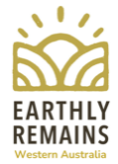

Keith Bradby OA
Gondwana Link
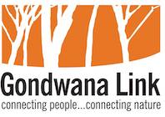
https://gondwanalink.org/
bradby@gondwanalink.org
Chair, Natural Transitions Council of Australia  email@zacharysequoia.com  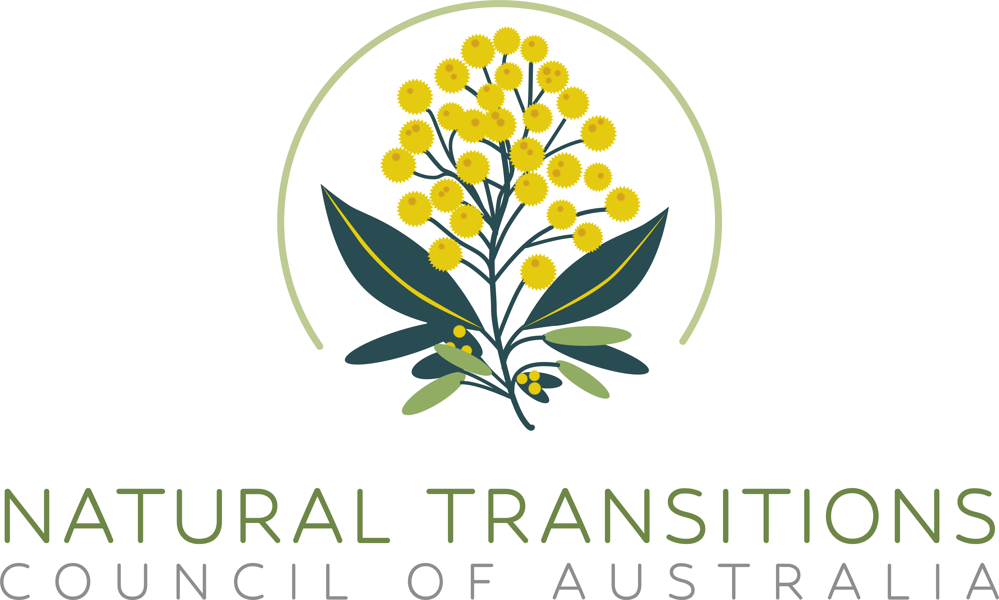  www.naturaltransitions.com.au | Tui Davidson  Founder, Earthly Remains  earthlyremainscanberra@gmail.com  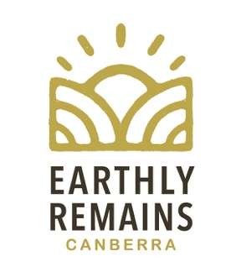

Further reading:
Human Composting
www.nytimes.com/interactive/2022/12/05/opinion/human-composting-new-y ork.html
Explains the Human Composting (or Natural Organic Reduction) process, as part of an op ed by Caitlyn Doughty, a mortician and author of three books on death and the funeral industry.

www.theguardian.com/society/2023/feb/19/human-composting-industry-deathcare
Profiles the growth of human composting start ups across America.

https://tenderfunerals.com.au/canberra/what-is-human-composting-and-why-would-we-do-it/
Explains the human composting process and how it is emerging as a ground-breaking and environmentally-friendly alternative to traditional burial and cremation methods.

Conservation based burials
www.conservationburialalliance.org/our_mission.html
The Conservation Burial Alliance brings together a number of conservation burial initiatives across the USA. They work within social and ecological spaces to engage people in community through a shared commitment to leaving an environmental legacy.
CBA believes that natural burial is a viable strategy for conserving intrinsically valuable land and restoring depleted landscapes while improving ecological health and promoting sustainable climate change mitigation.

Death Literacy
www.thelancet.com/commissions/value-of-death
2022 Report of The Lancet Commission on the Value of Death: Bringing death back into life Drawing on multidisciplinary perspectives from around the globe, the Commissioners argue that death and life are bound together: without death there would be no life. The Commission proposes a new vision for death and dying, with greater community involvement alongside health and social care services, and increased bereavement support.

Funeral Poverty
https://scholarship.richmond.edu/lawreview/vol55/iss2/2/
Funeral Poverty by Victoria J Haneman (2021)
This article makes a unique contribution to the literature by drawing attention to the financial burden of death service being shouldered by those who are “relatively poor,” or those for whom everyday life may be a financial struggle. The thesis is equal parts positive, normative, descriptive, and prescriptive: it is imperative that options be made available to transition human remains in a way that does not exacerbate cycles of poverty and allows for the living to preserve dignity.

https://insideageing.com.au/wp-content/uploads/2022/01/Australian-Funeral-Industry-Report-2021_Bare_FA.pdf
Bare. Australian Funeral Industry: State of the Nation 2021
An independent study of almost 3,500 Australians, commissioned by Bare Cremation and endorsed by University of Melbourne’s Dr Hannah Gould – a cultural anthropologist specialising in death and religion. According to the research the majority of Australians have attended at least one funeral in the last 5 years, yet do not know the options or requirements around end-of-life planning. Of those who had arranged a memorial and were dissatisfied; 70% felt that complaining would have been a waste of time and 49% didn’t know who to complain to.

Crematoria emissions and carbon footprint
https://edition.cnn.com/2022/11/07/world/human-composting-natural-organic-reduction-scn-lbg/index.html
How human composting could reduce death’s carbon footprint - CNN
"When human composting transforms the organic material of our bodies, carbon is also sequestered in the soil created. Rather than being released as carbon dioxide gas through exhaust during a cremation, the carbon matter contained in each body returns to the earth."

https://ncceh.ca/resources/evidence-reviews/crematoria-emissions-and-air-quality-impacts
Explores whether crematoria emit harmful pollutants of public health concern.

